2REN Churn Analytics – Leading Customer Retention Through Analytics Driven Change
Module 6 – Signature Assessment Assignment
ALY6120: Leadership in Analytics
Group 4
Presented By
Evans Coffie, Rita Manzie, Nighat Sultana, Rosy Pineda
Presented To
Professor Abeba N. Turi
December 13, 2025

Phase 1: Understanding the Business Problem
Overview of the Business Venture 2REN
2REN is a fictional mid-sized general e-commerce retailer that operates online and offers a broad range of products to customers anywhere in the region. Like many digital retailers, 2REN relies on high customer engagement and repeat purchasing behavior to maintain profitability. One key concern is that customer acquisition costs are high, and margins depend more on long-term customer value than on one-time sales.
With the competitive market in the e-commerce sector, customer retention is a critical success factor for 2REN. Customers can easily move between competing online retailers and have access to many alternative and lower-priced options, while also holding high expectations for service quality. Even small declines in retention can have a significant impact on revenue stability and customer lifetime value. This business venture positions 2REN to use an analytics-driven approach, where customer behavior, engagement patterns, and satisfaction can be analyzed to support retention strategies and data-driven decision-making.
2REN Problem Statement
2REN is experiencing customer churn, where current customers stop buying and interacting with the platform. This churn is impacting the company directly through key metrics such as revenue stability and customer lifetime value. Traditional retention efforts are often reactive, relying on broad promotional campaigns or post-disengagement outreach that fail to identify which customers are most at risk or the underlying drivers of churn. This highlights a gap in 2REN's current approach, where customer data exists but is not being used in a proactive way to prevent churn. By addressing customer churn through an analytics-driven approach, 2REN can shift toward proactive, evidence-based decision-making. From a leadership perspective, defining the churn problem and aligning analytical insights with business objectives ensures that analytics serves as a strategic tool.
2REN’s Business Objectives and Success Criteria
The main business objective for 2REN is to reduce customer churn by improving customer retention over the next 12 months. Specifically, the team aims to achieve a 20% improvement in retention by using analytics to identify customers who are most at risk of leaving and supporting more targeted retention efforts. A secondary objective is to improve the organization's ability to identify churn risk earlier in the customer lifecycle. Success for this initiative will be measured using both business and analytics-related metrics. From a business perspective, leadership will track retention lift, churn rate trends, changes in customer lifetime value, and improvements in retention campaign efficiency. From an analytics perspective, success will be evaluated based on churn-model performance, including accuracy and the model's ability to correctly identify customers at high risk of churn.
Leadership Perspective
As the leadership team guiding this analytics project for 2REN, we act as change agents responsible for connecting analytics to strategic goals and day-to-day operations. Our role is more than building predictive models, but also on defining the business problem, setting priorities, and creating the conditions needed for analytics to support effective decision-making. From our leadership SWOT analysis, there are identified key weaknesses that we have as leaders. This includes a tendency to take on overly complex ideas, hesitation to ask for help, and avoiding conflict to keep the peace. To address these risks, our leadership approach emphasizes clear boundaries, early understanding of assumptions, and open discussion during review of analytical results. We promote collaboration across roles to prevent over-reliance on individual effort and to reduce burnout by having equal responsibility and work. At the same time, our strengths in communication, adaptability, and data-driven thinking ensures analytics findings are translated clearly for both technical and non-technical stakeholders. We prioritize transparency, data privacy, and responsible use of churn predictions so that analytical outputs support ethical, actionable retention strategies for 2REN.
This phase reflects the Business Understanding stage of the CRISP-DM framework, where the problem, objectives, and success measures are defined and revisited as the analytics work progresses.
Phase 2: Understanding the Data for 2REN
Customer churn poses a challenge for e-commerce companies, as losing customers impacts revenue, market share, and long-term sustainability. Being able to predict which customers are likely to leave will allow companies to intervene with solutions on how to retain customers. The CRISP-DM framework describes that successful analytics projects start with the Data Understanding phase. This allows 2REN to assess analytics data sources, evaluate data quality, and ensure that there is an alignment with business goals and analytical capabilities (Collier, 2012).
Data Source and Context
The dataset used for this project is the “Ecommerce Customer Churn Analysis and Prediction” dataset created by Ankit Verma and published on Kaggle. It contains 5,630 observations and 20 variables describing transactional behavior, customer experience, demographic characteristics, and platform engagement patterns. The dataset is synthetic, meaning it imitates real customer distributions without exposing actual private data.
Data Limitations
We understand the dataset is synthetic, so it has its limitations that a real dataset won’t. It’s extremely useful for teaching, experimentation, and prototyping, but it contains several limitations:
- No real-world noise such as inconsistent formatting or duplicated customer IDs.
- Artificial distributions that may not represent 2REN’s true customer base.
- Uncertain causal relationships.
- Limited temporal detail such as missing transaction timelines or seasonality.
- Imputation removes information about original uncertainty.
Because of these constraints, the dataset should be viewed as a learning artifact. Real deployment requires repeating CRISP‑DM’s Data Understanding and Data Preparation phases on actual operational data.
Data Source connection to the Business Problem
Using this dataset allows us to model customer churn for 2REN. We can learn how churn can stem from different events such as gradual decline in engagement, service dissatisfaction, operational friction, or changes in customer needs. The key churn predictors that the dataset includes are tenure, engagement frequency, satisfaction scores, complaint history, spending behavior, and platform usage patterns, including specific variables like order count, time spent on the app, and coupons used. The variables are ideal for churn prediction research because they map directly to retention drivers (Neslin et al., 2006; Verbeke et al., 2012). The churn variable allows us to compare loyal customers with those who left, identify at-risk customers, and test targeted strategies such as personalized offers, proactive service outreach, or user experience improvements.
Data Quality Assessment
The original Excel dataset contains missing values across several key behavioral fields:
- Tenure: 264 missing (4.69 percent)
- WarehouseToHome: 251 missing (4.46 percent)
- HourSpendOnApp: 255 missing (4.53 percent)
- OrderAmountHikeFromLastYear: 265 missing (4.71 percent)
- CouponUsed: 256 missing (4.55 percent)
- OrderCount: 258 missing (4.58 percent)
- DaySinceLastOrder: 307 missing (5.45 percent)
All other variables contain 0 missing values. This pattern aligns with common ecommerce data challenges, where behavioral logs and transactional timestamps are more error‑prone than demographic records.
Variable Mapping to Business Problem
Each field contributes directly to understanding churn
Dataset Variable | Business Meaning | Why It Matters for Churn
Churn | Whether the customer left the platform | Target variable used to train the model
Tenure | Months customer has stayed | Longer tenure usually predicts lower churn
City Tier | Customer geography | Helps segment churn patterns by region
Gender | Demographic attribute | Used to see differences in retention behavior
Marital Status | Household indicator | Can shape spending stability
Preferred Payment Mode | How customer typically pays | Friction in payment choices can drive churn
Order Count | Total orders made | Core indicator of engagement and loyalty
Days Since Last Order | Recency of activity | One of the strongest churn warning signals
Cashback Amount | Value of incentives earned | Affects satisfaction and purchase motivation
Satisfaction Score | Customer sentiment | Dissatisfied customers churn faster
Complain | Whether customer raised a complaint | Complaints predict early churn if unresolved
Time on App | App usage time | Higher engagement lowers churn risk
Preferred Login Device | Mobile vs desktop etc. | Helps tailor retention experience across devices
Leadership Assessment of Data Readiness
From a leadership standpoint, this phase of the CRISP-DM focuses on understanding if the dataset for 2REN is sufficiently understood, reliable, and aligned with the churn business objective before advancing to modeling. Within the CRISP-DM framework, the Data Understanding phase emphasizes collecting data from relevant sources, conducting an exploring data analysis to understand the data, and checking data quality to make sure that the analytical work can be processed on a strong foundation (Schröer et al., 2021). As leaders in this initiative, we plan to evaluate how customer behavioral, transactional, and experience data would typically flow through operational systems and into an analytics environment. We also acknowledge risks such as missing behavioral data, use of synthetic data, and limited time-based data. By confirming data readiness in this way, we can determine whether it is appropriate to proceed to the next phase or if there is any additional clarification needed which is consistent with CRISP-DM guidance.
Phase 3: Data Preparation
Data Cleaning, Integration, and Preparation Plan
The dataset used in this study is the Ecommerce Customer Churn Analysis and Prediction dataset which is a synthetically generated eCommerce churn data set with 5630 customer records, 20 measured variables, and a binary churn indicator. Within these records, the dataset provides demographic characteristics (e.g., gender, marital status, city tier), behavioral metrics (e.g., number of orders, time spent on the application, satisfaction score), relationship indicators (e.g., complaints, cashback amount) and engagement features that are conventionally linked to churn propensity.
The data preparation includes steps to ensure that we have a clean dataset for modeling. Following recommendations of CRISP-DM methodology, missing values were handled using median imputation for numerical variables (Luna, 2021). Categorical variables contained no missing values, so mode imputation was not required. We will also validate all data types to make sure we store numerical types as an int or a float and temporal attributes in the same format. Duplicate customers will be checked and removed to avoid biased modeling results. Contrary to traditional outlier removal procedures that use only statistical thresholds, our methodology includes justification based on the context of the business. Outliers were handled by capping values at the 1st and 99th percentiles to reduce distortion while retaining high-value customers.
Finally, categorical variables like Gender, Marital Status, Preferred Payment Method, and City Tier will be converted to factors, with model pipelines handling encoding as needed. This methodology ensures that it is fully compatible with algorithms used in machine learning and makes it easy to integrate with subsequent modeling pipelines.
Early Findings
From our initial exploration of the dataset and after the data cleaning was completed, we discovered that the churn rate was about 16.8%, which indicates a class imbalance. This is typical for e-commerce retention problems. Customer tenure showed a median of 9 months, with values ranging from 9 to 61 months, reflecting a mix of newly acquired customers and long-term, loyal customers. Order behavior showed low frequency, with a median of 2, which may indicate that only a smaller subset of customers places orders more frequently. Engagement levels showed moderate daily usage, with customers spending a median of approximately 3 hours per day on the platform. These patterns confirm that the dataset captures realistic customer behaviors relevant to churn prediction.
Leadership During Data Preparation
Leadership during the data preparation stage emphasizes clarity, collaboration, and analytical empowerment. A key enhancement to this phase, based on professor feedback, was the inclusion of feature engineering as a central activity to strengthen predictive power in churn modeling. Several churn-relevant features were created to deepen the behavioral insights extracted from the dataset. These included recency measures derived from Days Since Last Order, frequency measures based on Order Count adjusted by tenure, tenure-based features distinguishing newly acquired and long-term customers, customer value indicators using Cashback Amount and Order Amount Hike from Last Year, and engagement intensity measures based on Time Spent on App. Each of these features provides meaningful insight into churn risk, as customers with lower engagement, declining activity, or higher reliance on incentives may be more likely to disengage.
Leadership also ensured that team members across roles were engaged throughout the data preparation process, consistent with CRISP-DM. Regular collaborative touchpoints such as weekly stand-ups, shared documentation, and iterative reviews of intermediate outputs supported transparency, psychological safety, and a shared sense of purpose. Team members were encouraged to question assumptions, validate engineered features, and identify emerging patterns, fostering an experimental and learning-oriented environment.
Phase 4: Modeling
Analytical Techniques and Models
As part of the CRISP-DM Modeling phase, we focus on selecting and developing models that help address 2REN’s customer churn problem. Classification models like logistic regression and random forest would help identify which factors causes churn and predict which customers are likely to leave (Lin, n.d.). Due to each model’s different techniques, each of them helps 2REN answer different but related questions. This approach makes sure that our analytics supports both operational decision-making and strategic planning.
Model Prioritization and Hierarchy
To ensure clarity and alignment with 2REN's business problem, we chose three different models that were prioritized than treated equally. Random Forest was chosen as the primary production model due to its predictive performance and because it works well for churn classification. Logistic regression was chosen as a supporting model to help explain the churn drivers and its interpretability. K-means clustering was used as a supporting segmentation model for customer retention actions across different customer profiles. This combination of different modeling approaches ensures that analytics outputs are both actionable and understandable for 2REN.
Primary Production Model: Random Forest
Random Forest was chosen as the main deployment model for 2REN due to its ability to handle complex non-linear relationships that show up in customer churn data. Customer behavior involves multiple variables such as engagement frequency, satisfaction, tenure, and incentive usage. With Random Forest, it can capture these without manually specifying how they interact. This model combines results from multiple decision trees to find patterns in churn behavior while reducing the risk of overfitting (DataCamp, 2024).
During our testing phase, Random Forest showed a strong predictive performance with an overall accuracy of 96.3%. It achieved 92% precision, 85% recall, and an F1 score of 88%. The model correctly identified 228 out of 269 customers who churned, which shows it's effective at capturing most at-risk customers while keeping false positives low.
Business-Calibrated Model Validation
Model validation at 2REN focuses on the business impact rather than technical metrics which aligns with the CRISP-DM focus on making sure analytics outputs support decision-making (Schröer et al., 2021). With churn analysis, recall is used to measure the churn capture in a model as it represents the proportion of customers who can be targeted for retention before they leave. With an 85% recall rate, the model allows the company to reach out to customers proactively instead of reacting after they've already left.
Precision is used to control retention spending. A precision rate of 92% shows that most customers flagged as at risk are truly likely to churn, which reduces unnecessary incentive distribution and limits wasted retention budget. False positives represent a measurable cost of trade-off instead of a statistical error. This business-focused validation makes sure that model performance translates into real financial outcomes instead of just abstract accuracy scores.
Supporting Models: Logistic Regression and K-means
While Random Forest is the main primary predictive model, we have selected two other models to help with the business problem. Logistic regression supports it by helping with interpretability and strategic understanding. It shows the direction and impact that individual features have on churn likelihood, which makes it easier to explain why customers leave. The accuracy that the logistic model performed in the testing phases was 89.3%, 70% precision, 58% recall, and an F1 score of 63%. This provides transparency that is valuable when communicating with stakeholders at 2REN. These insights help show that retention initiatives are more than immediate targeting decisions.
The other supportive model, K-means clustering, was used to segment customers based on behavioral patterns without needing predefined labels. The analysis found three distinct customer segments: moderate users with established tenure but limited purchasing activity, newer and at-risk customers with short tenure and low engagement, and loyal customers with high order frequency and sustained engagement. This segmentation supports the main model by showing how different groups should be treated once churn risk is identified. Rather than applying the same retention strategies to everyone, 2REN can create custom incentives and outreach based on customer value and engagement profiles.
Leadership Oversight, Governance, and Responsible Use
As we help guide through the modeling phase, as leaders, we ensure that analytical work remained aligned with 2REN’s business objective of improving customer retention rather than becoming just technical exercise. We prioritized models that could be clearly explained, trusted by stakeholders, and used by marketing and customer experience teams. In addition, we ensure to help 2REN recognizing that model uses depends on interpretability and business relevance rather than a predictive use. Throughout this phase, it's essential that there is cross-functional collaboration between analytics, engineering, and business stakeholders so that domain knowledge informed modeling decisions and assumptions were validated early. We also plan to establish governance barriers to support the responsible use of the model outputs which includes monitoring for unintended consequences, avoid over-targeting specific customer groups, and reinforcing consistent retention strategies. By emphasizing disciplined prioritization, transparency, and the iterative nature of the CRISP-DM framework, we ensured that churn modeling at 2REN supported ethical, effective, and sustainable decision-making while reinforcing a culture of data-driven leadership.
Phase 5: Evaluation
The Evaluation phase of the CRISP-DM framework focuses on determining whether the analytics solution addresses the original business problem and is ready to move toward deployment or needs more work. For 2REN, evaluation goes beyond just assessing technical model performance to determining whether churn predictions support retention strategy, align with leadership objectives, and deliver measurable business value. This phase serves as a formal decision checkpoint to make sure that analytical outputs are reliable, interpretable, and actionable before being put into operation (Schröer et al., 2021).
Evaluation Criteria and Business-Calibrated KPIs
Model success at 2REN is evaluated using a combination of technical performance measures and business-focused key performance indicators. Technical metrics like accuracy, precision, recall, and F1 score are used to confirm that models perform as expected and to compare predictive strength across different modeling approaches. These metrics support internal validation by confirming that churn predictions are statistically sound and can find meaningful patterns in customer behavior.
At the same time, business KPIs play a key role in evaluation to ensure alignment with the business problem in Phase 1. Key business metrics include churn rate reduction, retention lift, improvements in customer lifetime value, and the return on investment of targeted retention campaigns. These KPIs reflect leadership priorities by linking predictive performance to long-term customer value. Evaluating models against both technical and business measures ensures that analytical accuracy is translated into operational and strategic impact instead than just an isolated analytical outcome (Schröer et al., 2021).
Controls, Validation, and Risk Review
To ensure the integrity and reliability of analytical results, multiple validation controls are applied before deployment. Models are evaluated using structured validation approaches like train-test splits and confusion matrix analysis to assess classification outcomes and confirm that performance works beyond just the training data. These controls reduce the risk of overfitting and support confidence in model stability (Neslin et al., 2006).
A pre-deployment review is needed to confirm that models meet the performance requirements that align with business KPIs and can be put into operation within existing systems. This review looks at interpretability, reproducibility, and organizational feasibility. In addition, the evaluation of potential risks and ethical considerations such as data limitations, unintended targeting patterns, and misuse of churn predictions in customer interactions needs to be reviewed with stakeholders. Organizational readiness factors like system integration constraints and stakeholder preparedness are reviewed to ensure responsible and feasible deployment (Schröer et al., 2021).
Lessons Learned and Iterative Refinement
As we are guiding this analytics initiative, we treat evaluation as an iterative learning process instead of a one-time assessment. Insights gained during data understanding, preparation, and modeling helped refine feature selection, model prioritization, and validation criteria. Early assumptions about churn drivers were reviewed when patterns emerged, which help reinforced the importance of evidence-based refinement across CRISP-DM cycles. Through iterative CRISP-DM cycles, the original problem statement evolved from broadly reducing churn to specifically identifying high-risk customers early enough to enable cost-effective, targeted retention actions. These lessons directly informed readiness decisions and strengthened the overall evaluation framework.
Leadership Oversight and Ongoing Evaluation
Being responsible leaders to help aim for the long-term success of this initiative, we recognize that evaluation is an ongoing need. There is a plan for to the track model performance over time that includes changes in prediction accuracy, retention outcomes, and incentive efficiency. Performance in customer behavior will be reviewed regularly to determine when retraining or recalibration is needed, which aligns with CRISP-DM's focus on continuous improvement. We also plan to establish feedback loops with 2REN’s stakeholders to assess if the model-driven retention strategies are effective. Insights from marketing, customer service, and operations inform future CRISP-DM cycles to ensure that analytics stays aligned with evolving business goals and reinforces trust, accountability, and responsible use.
Phase 6: Deployment Plan
The churn model can be deployed using a batch-scoring pipeline. Based on evaluation, leadership decided to proceed with deployment under defined controls. Customer data flows into a warehouse daily or hourly. A scheduled job scores customers based on the trained model. API endpoints allow real-time scoring for actions like website personalization, mobile notifications, and in-session incentives.
Integration Points
- Marketing automation systems for sending targeted retention offers.
- CRM platforms for flagging high-risk customers automatically.
- Customer service dashboards for prioritizing outreach.
- Loyalty program engines for delivering dynamic reward levels
This design ensures alignment between predictive analytics and customer-facing actions.
Change Management and Adoption
When a customer is flagged as high churn-risk, three interventions activate:
- Automated personalized offer delivered through email or app
- Service follow-up if satisfaction score is low
- Behavioral nudge, such as product recommendations or reminders
Monitoring, Governance, and Continuous Improvement:
CRISP–DM iteration process: CRISP–DM is cyclical. Deployment is not the end; results feed back into new iterations of Business Understanding and Data Understanding.
Feedback loops:
- Compare predicted churn vs actual churn monthly
- Track conversion rates from retention interventions
- Monitor satisfaction score changes after outreach
- Conduct quarterly reviews with leadership
Model retraining approach: Retrain every 3–6 months or when accuracy drops. Add new behavioral features such as session depth or browsing categories. Evaluate fairness and avoid overfitting by monitoring stability across customer segments.
Infrastructure Diagram
From a leadership perspective, this infrastructure was designed to balance scalability, data governance, and operational integration.
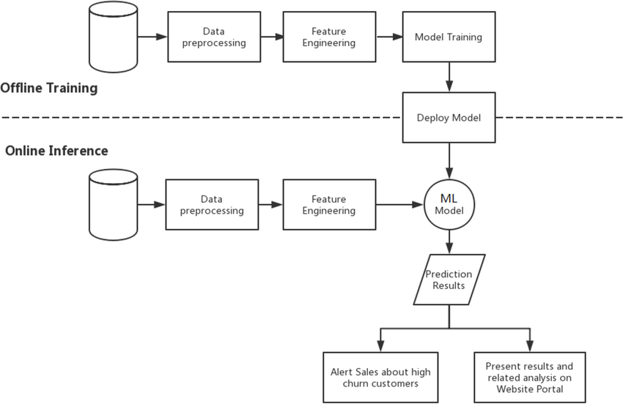
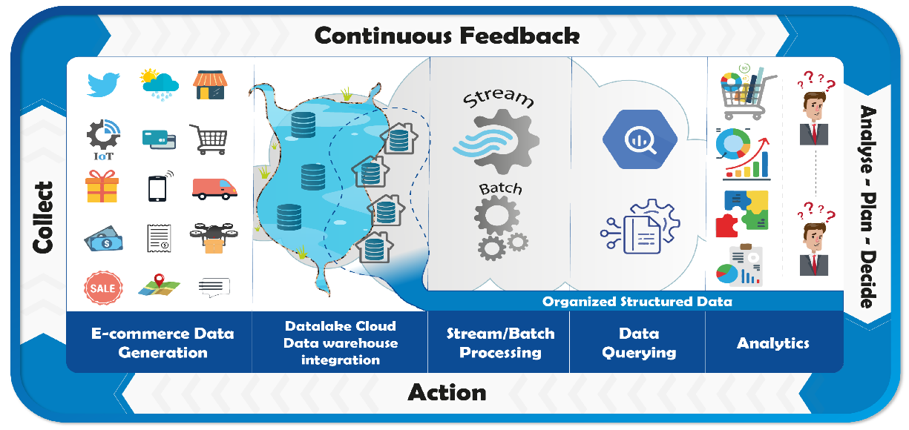
Figure 1. Data Flow for Churn Analytics Infrastructure
Customer interactions generate behavioral, transactional, and experience data. These flow into operational systems like CRM, order management, and mobile analytics. A centralized data warehouse integrates these sources into a structured dataset. The analytics environment performs feature engineering, model training, and scoring. Predictions feed business systems that run retention campaigns.
Leadership Style Conclusions
Leading with analytics throughout this project taught us the importance of clarity, communication, and structured problem framing. Rather than focusing solely on building models, our leadership role centered on guiding the analytics process, aligning technical work with 2REN’s business strategy, and ensuring that insights could be trusted and acted upon. Our team’s strengths include strong communication, adaptability, and alignment with business objectives, which supported responsible deployment of the churn model. At the same time, weaknesses identified in our SWOT such as overcomplexity and overcommitment highlighted the need for clear workflows and defined responsibilities. We learned that effective analytics leadership requires balancing technical accuracy with human factors like trust, collaboration, and transparency. Looking ahead, we see opportunities to evolve 2REN’s churn strategy through more advanced personalization and real-time data, with our leadership continuing to focus on translating analytics insights into sustained business value.

References
Collier, K. (2012). Agile analytics: A value-driven approach to business intelligence and data warehousing. IBM Press.
DataCamp. (2024, August 8). Classification in machine learning: An introduction. https://www.datacamp.com/tutorial/classification-machine-learning
Lin, S. (n.d.). 5 data science models for predicting enterprise churn. Reforge. https://www.reforge.com/blog/brief-5-data-science-models-for-predicting-enterprise-churn
Luna, Z. (2021, August 15). CRISP-DM phase 4: Modeling phase. Medium. https://medium.com/analytics-vidhya/crisp-dm-phase-4-modeling-phase-b81f2580ff3
Neslin, S. A., Gupta, S., Kamakura, W., Lu, J., & Mason, C. H. (2006). Defection detection: Measuring and understanding the predictive accuracy of customer churn models. Journal of Marketing Research, 43(2), 204–211.
Schröer, C., Kruse, F., & Gómez, J. M. (2021). A systematic literature review on applying CRISP-DM process model. Procedia Computer Science, 181, 526–534. https://doi.org/10.1016/j.procs.2021.01.199
Verbeke, W., Dejaeger, K., Martens, D., Hur, J., & Baesens, B. (2012). New insights into churn prediction in the telecommunication sector. European Journal of Operational Research, 218(1), 211–229.
Verma, A. (n.d.). Ecommerce customer churn analysis and prediction [Dataset]. Kaggle. https://www.kaggle.com/datasets/ankitverma2010/ecommerce-customer-churn-analysis-and-prediction

